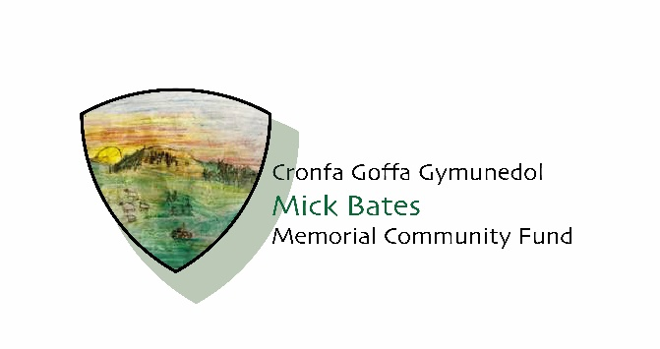
Grant Application
We welcome applications of up to £1000
E-mail your completed form and any supporting documents to: Ruth Bates ruthannbates@hotmail.co.uk
Deadline for applications is 1pm on Friday, August 01 2025 and will then be considered by the Trustees.

Guidance
- The purpose of this form is to let us know what you need, and how we may be able to help.

Process
- Once you have submitted your application, it will be assessed by our Trustees.

Privacy Notice
In order to process your application, we need to record your details on our database. Please tick the box to acknowledge that you give permission for us to hold your data for grant-making purposes. The information will not be shared with any other party without your explicit permission.
☐ | Yes
☐ | No

About you
First name:
Last name:
E-mail:
Contact number:
Role within the organisation:

About your organisation
Name of organisation:
Registered address:

Type of organisation:

Registered numbers(s) eg. Registered Charity Number /if unregistered please share your constitution with us.
Organisations bank account: Please provide the name, account number and sort code.
Social Media (Twitter, Facebook, Instagram etc.)
Website:

What does your organisation do?

Does your organisation work with children, young people and vulnerable adults?
☐ | Yes | ☐ | No

If yes, a copy of your Safeguarding Policy should be included.

Details of your project
- How much are you applying for from the Mick Bates Community Memorial Fund? (Minimum £100 and maximum is £1000)

- Please tell us what you would like to do with the funding? We’d like to know more about what you intend to do.

- What difference will your project make and to whom?
We’d like to know more about who will benefit from your project.

- How have you identified the need for the project?
We’d like to know more about how you have identified the importance of the project to the people that will benefit.

- Please tell us exactly what you will spend the money on?
We’d like a breakdown of the type of things you will be spending the money on.

- What are the timescales of your project?
Start Date: |  | End  Date:

Location
- Where will your project take place? Please specify village/town.

- How did you hear about us?

I declare that the information given above is, to the best of my knowledge, true and correct.

Signature: ______________________________ Date: __________________

